2015

www.costvsvalue.com

YOUR TOOLBOX FOR SUCCESS

2015

Midrange Project Descriptions

ATTIC BEDROOM REMODEL

Convert unfinished attic space to a 15-by-15-foot bedroom and a 5-by-7-foot bathroom with shower. Include a 15-foot shed dormer, four new windows, and closet space under the eaves. Insulate and finish ceiling and walls. Carpet floor.

Extend existing HVAC to new space; provide electrical wiring and lighting to code. Retain existing stairs, but add rail and baluster around stairwell.

BACKUP POWER GENERATOR

Install modular electrical backup system with capacity for providing 70 amps of emergency power in two 240-volt circuits and six 120-volt circuits. Assume existing propane gas supply. Include generator mounted on 2-by-4-four-foot concrete or composite pad, automatic transfer switch, load center, exterior disconnect, and grounding rod. Include 30 feet of conduit and electrical cable for generator connections; grounded cable for circuits; 5 feet of flexible fuel line for connection to existing rigid gas supply line; and automotive-type storage battery.

BASEMENT REMODEL

Finish the lower level of a house to create a 20-by-30-foot entertaining area with wet bar and a 5-by-8-foot full bathroom; construct 24 linear feet of finished partition to enclose mechanical area. Walls and ceilings are painted

drywall throughout; exterior walls are insulated; painted trim throughout. Include five six-panel factory-painted hardboard doors with passage locksets. Electrical wiring to code.

Main room: Include 15 recessed ceiling light fixtures and three surface-mounted light fixtures, and a snap-together laminate flooring system.

Bathroom: Include standard white toilet, vanity with cultured marble top, resilient vinyl flooring, two-piece fiberglass shower unit, a light/fan combination, vanity light fixture, recessed medicine cabinet, towel and paper-holder hardware.

Bar area: Include 10 linear feet of raised-panel oak cabinets with laminate countertops, stainless steel bar sink, single-lever bar faucet, undercounter refrigerator, and vinyl floor tile.

BATHROOM ADDITION

Add a full 6-by-8-foot bathroom over a crawlspace with poured concrete walls. Include cultured-marble vanity top with molded sink; standard chrome faucets; 30-by-60-inch white fiberglass tub/shower with ceramic tile surround; single-lever temperature and pressure-balanced faucet; white low-profile toilet; general and spot lighting; electrical wiring to code; mirrored medicine cabinet; linen storage closet or cabinet; vinyl wallpaper; painted trim; and ceramic tile floor.

BATHROOM REMODEL

Update an existing 5-by-7-foot bathroom. Replace all fixtures

to include 30-by-60-inch porcelain-on-steel tub with 4-by-4-inch ceramic tile surround; new single-lever temperature and pressure-balanced shower control; standard white toilet; solid-surface vanity counter with integral sink; recessed medicine cabinet with light; ceramic tile floor; vinyl wallpaper.

DECK ADDITION (WOOD)

Add a 16-by-20-foot deck using pressure-treated joists supported by 4x4 posts anchored to concrete piers. Install pressure-treated deck boards in a simple linear pattern. Include a built-in bench and planter of the same decking material. Include stairs, assuming three steps to grade. Provide a complete railing system using pressure-treated wood posts, railings, and balusters.

DECK ADDITION (COMPOSITE)

Add a 16-by-20-foot deck using pressure-treated joists supported by 4x4 posts anchored to concrete piers. Install composite deck material in a simple linear pattern. Include a built-in bench and planter of the same decking material. Include stairs, assuming three steps to grade. Provide a complete railing using a matching system made of the same composite as the decking material.

ENTRY DOOR REPLACEMENT (STEEL)

Remove existing 3-0/6-8 entry door and jambs and replace with new 20-gauge steel unit, including clear dual-pane half-glass panel, jambs, and aluminum threshold with composite stop. Door is factory finished with same color both sides. Exterior brick-mold and 2.5-inch interior colonial or ranch casings in poplar or equal prefinished to match door color. Replace existing lockset with new bored-lock in brass or antique-brass finish.

ENTRY DOOR REPLACEMENT (FIBERGLASS)

Remove existing 3-0/6-8 entry door and jambs and replace with new fiberglass unit with simulated wood grain, stained same color both sides; dual-pane, decorative half-glass panel with zinc caming; PVC-wrapped exterior trim in color to match existing trim; 2.5-inch interior colonial or ranch casings in hardwood stained to match door. Replace existing lockset with mortise lock with lever handle and integrated deadbolt in oil-rubbed bronze or satin-nickel finish.

FAMILY ROOM ADDITION

In a style appropriate to the existing house, add a 16-by-25-foot room on a crawlspace foundation with vinyl siding and fiberglass shingle roof. Include drywall interior with fiberglass insulation, pre-finished hardwood floor, and 180 square feet of glazing including windows, atrium-style exterior doors, and two operable skylights. Tie into existing HVAC. Add electrical system to code, including 12 recessed ceiling lights.

2015

GARAGE ADDITION

Construct a 26-by-26-foot freestanding two-car garage, including footings and slab-on-grade foundation, 2x4 wood frame with OSB structural sheathing, and gable truss roof at 6/12 pitch. Install 25-year asphalt shingle roofing with galvanized metal flashing; vinyl siding and trim. Install five double-hung 30-by-48-inch vinyl windows; one 3-0/6-8 exterior door with half-glass and lockset; and two composite 9-by-8-foot overhead doors with motorized openers. Include 100-amp breaker at main house panel and 50 linear feet of trench buried conduit to feed new electrical subpanel. Provide electrical wiring for openers; three-way switching for fluorescent ceiling fixtures over each bay; three-way switching for two exterior spotlights; outlets to code. Interior wall, floors, and ceilings remain unfinished.

GARAGE DOOR REPLACEMENT

Remove and dispose of existing 16-by-7-foot garage door and tracks. Install new 4-section garage door on new galvanized steel tracks; reuse existing motorized opener. New door is uninsulated, single-layer, embossed steel with two coats of baked-on paint, galvanized steel hinges, and nylon rollers; 10-year limited warranty.

HOME OFFICE REMODEL

Convert an existing 12-by-12-foot room to a home office. Install custom cabinets to include 20 linear feet of laminate desktop, computer workstation, and wall cabinet storage. Rewire room for computer, fax machine, and other electronic equipment, as well as cable and telephone lines. Include drywall interior, painted trim, and commercial-grade carpeting.

MAJOR KITCHEN REMODEL

Update an outmoded 200-square-foot kitchen with a functional layout of 30 linear feet of semi-custom wood cabinets, including a 3-by-5-foot island; laminate countertops; and standard double-tub stainless-steel sink with standard single-lever faucet. Include energy-efficient wall oven, cooktop, ventilation system, built-in

microwave, dishwasher, garbage disposal, and custom lighting. Add new resilient flooring. Finish with painted walls, trim, and ceiling.

MASTER SUITE ADDITION

Add a 24-by-16-foot master bedroom suite over a crawlspace. Include walk-in closet/dressing area, whirlpool tub in ceramic tile platform, separate 3-by-4-foot ceramic tile shower, and double-bowl vanity with solid-surface countertop. Bedroom floor is carpet; bathroom floor is ceramic tile. Painted walls, ceiling, and trim. General and spot lighting, exhaust fan; electrical wiring to code.

MINOR KITCHEN REMODEL

In a functional but dated 200-square-foot kitchen with 30 linear feet of cabinetry and countertops, leave cabinet boxes in place but replace fronts with new raised-panel wood doors and drawers, including new hardware. Replace wall oven and

cooktop with new energy-efficient models. Replace laminate countertops; install midpriced sink and faucet. Repaint trim, add wall covering, and remove and replace resilient flooring.

ROOFING REPLACEMENT

Remove existing roofing to bare wood sheathing and dispose of properly. Install 30 squares of 235-pound fiberglass asphalt shingles (min. 25-year warranty) with new felt underlayment, galvanized drip edge, and mill-finish aluminum flashing. Assume a 5-square hip roof; custom flashing at two average-size skylights; and custom cap treatment at vented ridge.

SIDING REPLACEMENT

Replace 1,250 square feet of existing siding with new vinyl siding, including all trim.

STONE VENEER ACCENT (MIDRANGE)

Remove a 300 square-foot continuous band of existing vinyl siding from the bottom third of the street-facing façade, beginning at the garage, continuing around the main entry, and ending at the corner of the side addition. Replace with adhered manufactured stone veneer, including 36 linear feet (LF) of sills, 40 LF of corners, and 1 address block. Installation includes 2 separate layers of water resistive barrier laid over bare sheathing, corrosion resistant lath and fasteners, and nominal 1Ž2-inch-thick mortar scratch coat and setting bed. Outline the archway using an 8x10-inch keystone and a soldier course of flats on either side.

SUNROOM ADDITION

Construct a 200-square-foot sunroom addition, including footings and slab-on-grade foundation. Post-and-beam framing exposed on interior side. Wall glazing: vinyl or aluminum

clad awning and casement windows with low-E, laminated or tempered glazing and screens. Roof glazing: 10 large aluminum-clad venting skylights with screens. Provide ceiling fan; insulate all non-glass areas; provide movable shades for glass area. Quarry tile or equal on floor.

TWO-STORY ADDITION

Add a first-floor family room and a second-floor bedroom with full bathroom in a 24-by-16-foot two-story wing over a crawlspace. Add new HVAC system to handle addition; electrical wiring to code.

Family room: Include a prefabricated gas fireplace; 11 3-by-5-foot double-hung insulated clad-wood windows; an atrium-style exterior door; carpeted floors; painted drywall on walls and ceiling; and painted trim.

Bathroom: 5 by 8 feet. Include a one-piece fiberglass tub/shower unit; standard white toilet; wood vanity with solid-surface countertop; resilient vinyl flooring; and mirrored medicine cabinet with built-in light strip; papered walls; and painted trim; exhaust fan. Bedroom: Include walk-in closet/dressing area; carpet; painted walls, ceiling, and trim; general and spot lighting.

2015

WINDOW REPLACEMENT (VINYL)

Replace 10 existing 3-by-5-foot double-hung windows with insulated vinyl replacement windows. Wrap existing exterior trim as required to match. Do not disturb existing interior trim.

WINDOW REPLACEMENT (WOOD)

Replace 10 existing 3-by-5-foot double-hung windows with insulated wood replacement windows, exterior clad in vinyl or aluminum. Wrap existing exterior trim as required to match. Do not disturb existing interior trim.

Upscale Project Descriptions

BATHROOM ADDITION

Add a new 100-square-foot master bathroom to existing master bedroom over a crawlspace. Include 42-by-42-inch neo-angle shower with ceramic tile walls with accent strip, recessed shower caddy, body-spray fixtures, and frameless glass enclosure. Include a customized whirlpool tub; stone countertop with two sinks; two mirrored medicine cabinets with lighting; a compartmentalized commode area with one-piece toilet; and a humidistat-controlled exhaust fan. Use all color fixtures. Use larger matching ceramic tiles on the floor, laid on the diagonal with ceramic tile base molding. Add general and spot lighting including waterproof shower fixture. Cabinetry shall include a custom drawer base and wall cabinets for a built-in look. Extend HVAC system, and include electric in-floor heating and heated towel bars.

BATHROOM REMODEL

Expand an existing 35-square-foot bathroom to 100 square feet within existing house footprint. Relocate all fixtures. Include 42-by-42-inch neo-angle shower with ceramic tile walls with accent strip, recessed shower caddy, body-spray fixtures, and frameless glass enclosure. Include a customized whirlpool tub; stone countertop with two sinks; two mirrored medicine cabinets with lighting; a compartmentalized commode area with one-piece toilet; and a humidistat-controlled exhaust fan. Use all color fixtures. Use larger matching ceramic tiles on the floor, laid on the diagonal with ceramic tile base molding. Add general and spot lighting including waterproof shower fixture. Cabinetry shall include a custom drawer base and wall cabinets for a built-in look. Extend HVAC system, and include electric in-floor heating and heated towel bars.

DECK ADDITION (COMPOSITE)

Add a 16-by-20-foot deck using pressure-treated joists supported by 4x4 posts anchored to concrete piers. At one corner, add a second, 10-foot-diameter six-sided platform one step down from the main deck. Include stairs on the smaller deck, assuming three steps to grade. Install composite deck

material in a simple linear pattern. Trim the perimeter joists and wrap the 4x4 posts with composite materials to match the decking. Using the same decking material, include a built-in bench and planter along one 16-foot side. On the remaining perimeter, provide a railing system using composite material of contrasting or complementary colors that includes decorative balusters, post caps, and lighting. Railing and trim should provide for overall curb appeal to the outdoor living space by integrating the deck with the home’s color and architecture, creating a custom look.

GARAGE ADDITION

For the same midrange two-car garage, add interior wall finish using moisture-resistant drywall on ceiling and three walls. At rear wall, install modular storage systems including wall panels, upper and lower storage cabinets with work surfaces, and required task lighting. Trim all windows and doors and provide base molding at perimeter; paint all trim, ceiling, and walls. Finish cement floor with color, slip-resistant epoxy sealer.

GARAGE DOOR REPLACEMENT

Remove and dispose of existing 16x7-foot garage door and tracks. Install new 4-section garage door on new heavy-duty galvanized steel tracks; reuse existing motorized opener. New door is high tensile strength steel with two coats of factory-applied paint and foam insulated to minimum R-12 with thermal seals between pinch-resistant panels. Windows in top panel are ½-inch insulated glass. Hardware includes galvanized steel hinges and ball-bearing urethane rollers. Lifetime warranty.

GRAND ENTRANCE (FIBERGLASS)

Remove existing 3-0/6-8 entry door and cut and reframe opening for a 12-36-12 entrance door with dual sidelites. Move double-gang electrical box with two switches. Fiberglass door blank matches upscale entry, including color, threshold, lockset, and decorative half-glass; sidelites match door. PVC-wrapped exterior trim in color to match existing trim; wider interior colonial or ranch casings (3.5-inch to cover new jack studs) in hardwood stained to match door. All work to be completed in one day.

MAJOR KITCHEN REMODEL

Update outmoded 200-square-foot kitchen with 30 linear feet of top-of-the-line custom cherry cabinets with built-in sliding shelves and other interior accessories. Include stone countertops with imported ceramic- or glass-tile backsplash; built-in refrigerator, cooktop, and 36-inch commercial grade range and vent hood; built-in warming drawer, trash compactor, and built-in combination microwave and convection oven. Install high-end undermount sink with designer faucets and built-in water filtration system. Add new general and task lighting including low-voltage undercabinet lights. Install cork flooring, cherry trim.

2015

MASTER SUITE ADDITION

Add a 32-by-20-foot master bedroom suite over a crawlspace. Bedroom: Add a spacious sleeping area with lounging/sitting area adjacent to large master bathroom. Include custom bookcases and built-in storage with millwork details; high-end gas fireplace with stone hearth and custom mantle; and large walk-in closet/dressing area with natural light, mirrors, and linen storage. Add French doors to exterior.

Bathroom: Include a large walk-in shower with dual-shower system, stone shower walls and floor, and custom frameless glass enclosure. Add corner-design whirlpool tub bordered on two sides by windows and built into granite or marble platform with custom cabinet front. Include two sinks in separate custom vanities with stone countertops and large mirrors. Create partitioned area for luxury one-piece toilet.

General: Add 5-foot-long hospitality center with bar sink, undercounter refrigerator, custom cabinetry, granite or marble countertop, and microwave. Include soundproofing, in-floor heating, custom wall finishes and hardware, general and spot lighting, and lighting controls.

ROOFING REPLACEMENT

Remove existing roofing to bare wood sheathing and dispose of properly. Install 30 squares of standing-seam metal, formed on site into 16-inch panels using factory-enameled roll steel; double-lock all seams. Use custom brake-bent flashing from same material for drip edge and all flashing at roof-wall intersections. Assume a 5-square hip roof; custom flashing

at two average-sized skylights; and custom cap treatment at vented ridge. Apply over new felt underlayment; use ice-and-water membrane at eaves, valleys, and all penetrations.

SIDING REPLACEMENT (FIBER-CEMENT)

Replace 1,250 square feet of existing siding with new fiber-cement siding, factory primed and factory painted. Include all 4/4 and 5/4 trim using either fiber-cement boards or cellular PVC.

SIDING REPLACEMENT (FOAM-BACKED VINYL)

Replace 1,250 square feet of existing siding with new foam-backed vinyl siding, including factory trim at all openings and corners.

WINDOW REPLACEMENT (VINYL)

Replace 10 existing 3-by-5-foot double-hung windows with insulated, low-E, simulated-divided-lite vinyl windows. Simulated wood-grain interior finish; custom-color exterior finish. Trim exterior to match existing; do not disturb existing interior trim.

WINDOW REPLACEMENT (WOOD)

Replace 10 existing 3-by-5-foot double-hung windows with insulated, low-E, simulated-divided-lite wood windows. Interior finish of stained hardwood; exterior finish of custom-color aluminum cladding. Trim exterior to match existing; do not disturb existing interior trim.

Reuse and Licensing of Data

COPYRIGHTED MATERIAL

The Remodeling Cost vs. Value Report contains copyrighted mate-rial that is being made available in free downloadable PDF docu-ments as a public service. Any reuse without express permission is prohibited, including but not limited to the following:

- RESALE. The Cost vs. Value Report, whether in whole or part, may not be reproduced and sold in any format, including print, digi-tal, electronic file, fax, or other medium.

- PUBLICATION OF DATA. The Cost vs. Value Report, whether in whole or part, may not be distributed or published in any format, including print, digital, electronic file, fax, or other medium without obtaining express permission.

- APPLICATIONS/SOFTWARE. The Cost vs. Value Report, whether in whole or part, may not be incorporated for use in any kind of computer- or Web-based application, calculator, database, or other automated, electronic, or digital device, instrument, or soft-ware except as licensed by Hanley Wood (see Licensing, below).

EXCERPTING COST VS. VALUE REPORT DATA

Excerpts of Cost vs. Value Report data may not take the form of a chart or table that simulates the manner in which the data is dis-played at www.costvsvalue.com.

Excerpts of Cost vs. Value Report data may, however, be made as part of a narrative, provided that the sum total of all excerpts from any publisher in all formats does not exceed data from more than five projects.

ACKNOWLEDGING COST VS. VALUE AS DATA SOURCE

When excerpting Cost vs. Value Report data, refer to the “Remodel-ing 2015 Cost vs. Value Report” and include the URL www.costvs-value.com, as in the following examples:

- “... according to the Remodeling 2015 Cost vs. Value Report (www. costvsvalue.com) ...”

- “… as compiled in the Remodeling 2015 Cost vs. Value Report (www.costvsvalue.com) ....”

This form of citation should be used in the first instance on every page of a multipage online story that cites the Cost vs. Value Report on multiple pages. Subsequent references on a given page may be foreshortened to “Cost vs. Value Report.”

All excerpts must be accompanied by one or more instances of the following acknowledgements of copyright:

“© 2015 Hanley Wood, LLC. Complete data from the Remodel-ing 2015 Cost vs. Value Report can be downloaded free at www. costvsvalue.com.”

LICENSING OF 2015 COST VS. VALUE REPORT DATA

For permission to license data from the 2015 Cost vs. Value Report for use in any kind of computer- or Web-based application, calcula-tor, database, or other automated, electronic, or digital device, instrument, or software, include the following in an email request to costvsvaluepermissions@hanleywood.com

- a description of the application, calculator, or device for which use of the data is being requested. Include the length of time for which the license is sought.

- a detailed description of the material to be licensed (e.g., specific projects, cities, etc.).

 | PROJECT TYPE
 |  |  | SEATTLE
 |  | Job | Resale | Cost
 | MIDRANGE | Cost | Value | Recouped
 | Attic Bedroom Remodel | $58,532 | $49,092 | 83.9%
 | Backup Power Generator | 13,100 | 7,224 | 55.1%
 | Basement Remodel | 73,435 | 66,325 | 90.3%
 | Bathroom Addition | 44,387 | 32,991 | 74.3%
 | Bathroom Remodel | 19,052 | 15,347 | 80.6%
 | Deck Addition (wood) | 11,444 | 10,333 | 90.3%
 | Deck Addition (composite) | 17,124 | 14,014 | 81.8%
 | Entry Door Replacement (steel) | 1,344 | 1,669 | 124.2%
 | Entry Door Replacement (fiberglass) | 3,074 | 2,664 | 86.7%
 | Family Room Addition | 92,287 | 77,153 | 83.6%
 | Garage Addition | 56,666 | 45,795 | 80.8%
 | Garage Door Replacement | 1,721 | 2,087 | 121.3%
 | Home Office Remodel | 32,051 | 17,070 | 53.3%
 | Major Kitchen Remodel | 61,475 | 50,617 | 82.3%
 | Master Suite Addition | 120,336 | 94,247 | 78.3%
 | Minor Kitchen Remodel | 21,122 | 20,502 | 97.1%
 | Roofing Replacement | 21,009 | 15,236 | 72.5%
 | Siding Replacement (vinyl) | 13,741 | 10,320 | 75.1%
 | Sunroom Addition | 82,370 | 44,362 | 53.9%
 | Two-Story Addition | 177,717 | 144,633 | 81.4%
 | Window Replacement (vinyl) | 11,259 | 10,697 | 95.0%
 | Window Replacement (wood) | 12,283 | 12,215 | 99.5%
 | Stone Veneer Accent | 7,126 | 7,213 | 101.2%
 |  | Job | Resale | Cost
 | UPSCALE | Cost | Value | Recouped
 | Bathroom Addition | $81,752 | $60,224 | 73.7%
 | Bathroom Remodel | 57,896 | 42,513 | 73.4%
 | Deck Addition (composite) | 39,611 | 25,921 | 65.4%
 | Garage Addition | 93,395 | 64,694 | 69.3%
 | Garage Door Replacement | 3,077 | 3,401 | 110.5%
 | Grand Entrance | 7,928 | 6,111 | 77.1%
 | Major Kitchen Remodel | 121,242 | 87,538 | 72.2%
 | Master Suite Addition | 252,202 | 158,610 | 62.9%
 | Roofing Replacement | 40,358 | 27,117 | 67.2%
 | Siding Replacement (fiber-cement) | 16,049 | 14,748 | 91.9%
 | Siding Replacement (foam-backed vinyl) | 16,931 | 12,417 | 73.3%
 | Window Replacement (vinyl) | 14,897 | 13,230 | 88.8%
 | Window Replacement (wood) | 18,488 | 15,785 | 85.4%
This document contains copyrighted material and is not authorized for display on the Internet or for republication in any media for resale.

©2015 Hanley Wood, LLC. Republication or dissemination of Remodeling’s 2015 Cost vs. Value Report is expressly prohibited without the written permission of Hanley Wood, LLC. “Cost vs. Value” is a registered trademark of Hanley Wood, LLC. Unauthorized use is prohibited.

 | PROJECT TYPE
 |  |  | PACIFIC
 |  | Job | Resale | Cost
 | MIDRANGE | Cost | Value | Recouped
 | Attic Bedroom Remodel | $60,675 | $55,646 | 91.7%
 | Backup Power Generator | 13,226 | 8,985 | 67.9%
 | Basement Remodel | 75,596 | 70,077 | 92.7%
 | Bathroom Addition | 45,635 | 33,715 | 73.9%
 | Bathroom Remodel | 19,436 | 16,681 | 85.8%
 | Deck Addition (wood) | 11,685 | 11,828 | 101.2%
 | Deck Addition (composite) | 17,484 | 13,995 | 80.0%
 | Entry Door Replacement (steel) | 1,366 | 1,683 | 123.0%
 | Entry Door Replacement (fiberglass) | 3,107 | 2,845 | 91.6%
 | Family Room Addition | 94,746 | 74,674 | 78.8%
 | Garage Addition | 59,348 | 47,279 | 79.7%
 | Garage Door Replacement | 1,756 | 1,929 | 110.0%
 | Home Office Remodel | 32,652 | 18,364 | 56.2%
 | Major Kitchen Remodel | 62,441 | 50,650 | 81.1%
 | Master Suite Addition | 122,894 | 90,608 | 73.7%
 | Minor Kitchen Remodel | 21,497 | 21,987 | 102.3%
 | Roofing Replacement | 21,938 | 18,094 | 82.5%
 | Siding Replacement (vinyl) | 14,134 | 12,571 | 88.9%
 | Sunroom Addition | 83,694 | 47,488 | 56.7%
 | Two-Story Addition | 183,801 | 136,524 | 74.3%
 | Window Replacement (vinyl) | 11,465 | 10,372 | 90.5%
 | Window Replacement (wood) | 12,489 | 11,911 | 95.4%
 | Stone Veneer Accent | 7,258 | 7,808 | 107.6%
 |  | Job | Resale | Cost
 | UPSCALE | Cost | Value | Recouped
 | Bathroom Addition | $83,004 | $58,906 | 71.0%
 | Bathroom Remodel | 60,432 | 42,023 | 69.5%
 | Deck Addition (composite) | 40,302 | 27,716 | 68.8%
 | Garage Addition | 96,500 | 61,915 | 64.2%
 | Garage Door Replacement | 3,096 | 3,192 | 103.1%
 | Grand Entrance | 8,016 | 6,485 | 80.9%
 | Major Kitchen Remodel | 123,087 | 85,063 | 69.1%
 | Master Suite Addition | 254,422 | 157,448 | 61.9%
 | Roofing Replacement | 42,737 | 30,200 | 70.7%
 | Siding Replacement (fiber-cement) | 16,405 | 15,988 | 97.5%
 | Siding Replacement (foam-backed vinyl) | 17,296 | 15,314 | 89.0%
 | Window Replacement (vinyl) | 15,109 | 13,595 | 90.0%
 | Window Replacement (wood) | 18,719 | 16,706 | 89.2%
 |  | CONFIDENCE LEVEL: | 95% +/-4.44

This document contains copyrighted material and is not authorized for display on the Internet or for republication in any media for resale.

©2015 Hanley Wood, LLC. Republication or dissemination of Remodeling’s 2015 Cost vs. Value Report is expressly prohibited without the written permission of Hanley Wood, LLC. “Cost vs. Value” is a registered trademark of Hanley Wood, LLC. Unauthorized use is prohibited.

 | PROJECT TYPE
 |  | 2015 NATIONAL AVERAGES
 |  | Job | Resale | Cost
 | MIDRANGE | Cost | Value | Recouped
 | Attic Bedroom Remodel | $51,696 | $39,908 | 77.2%
 | Backup Power Generator | 12,135 | 7,263 | 59.9%
 | Basement Remodel | 65,442 | 47,637 | 72.8%
 | Bathroom Addition | 39,578 | 22,875 | 57.8%
 | Bathroom Remodel | 16,724 | 11,707 | 70.0%
 | Deck Addition (wood) | 10,048 | 8,085 | 80.5%
 | Deck Addition (composite) | 15,912 | 10,816 | 68.0%
 | Entry Door Replacement (steel) | 1,230 | 1,252 | 101.8%
 | Entry Door Replacement (fiberglass) | 2,926 | 2,107 | 72.0%
 | Family Room Addition | 84,201 | 53,955 | 64.1%
 | Garage Addition | 52,382 | 33,938 | 64.8%
 | Garage Door Replacement | 1,595 | 1,410 | 88.4%
 | Home Office Remodel | 29,066 | 14,155 | 48.7%
 | Major Kitchen Remodel | 56,768 | 38,485 | 67.8%
 | Master Suite Addition | 111,245 | 68,596 | 61.7%
 | Minor Kitchen Remodel | 19,226 | 15,255 | 79.3%
 | Roofing Replacement | 19,528 | 13,975 | 71.6%
 | Siding Replacement (vinyl) | 12,013 | 9,694 | 80.7%
 | Sunroom Addition | 75,726 | 36,704 | 48.5%
 | Two-Story Addition | 161,925 | 103,848 | 64.1%
 | Window Replacement (vinyl) | 11,198 | 8,163 | 72.9%
 | Window Replacement (wood) | 11,341 | 8,937 | 78.8%
 | Stone Veneer Accent | 7,150 | 6,594 | 92.2%
 |  | Job | Resale | Cost
 | UPSCALE | Cost | Value | Recouped
 | Bathroom Addition | $76,429 | $44,750 | 58.6%
 | Bathroom Remodel | 54,115 | 32,385 | 59.8%
 | Deck Addition (composite) | 36,385 | 21,437 | 58.9%
 | Garage Addition | 85,592 | 46,791 | 54.7%
 | Garage Door Replacement | 2,944 | 2,429 | 82.5%
 | Grand Entrance | 7,548 | 5,099 | 67.6%
 | Major Kitchen Remodel | 113,097 | 66,747 | 59.0%
 | Master Suite Addition | 236,363 | 126,860 | 53.7%
 | Roofing Replacement | 36,329 | 22,840 | 62.9%
 | Siding Replacement (fiber-cement) | 14,014 | 11,816 | 84.3%
 | Siding Replacement (foam-backed vinyl) | 15,184 | 11,790 | 77.6%
 | Window Replacement (vinyl) | 13,837 | 10,365 | 74.9%
 | Window Replacement (wood) | 17,422 | 12,533 | 71.9%
CONFIDENCE LEVEL: 95% +/- 1.82

This document contains copyrighted material and is not authorized for display on the Internet or for republication in any media for resale.

©2015 Hanley Wood, LLC. Republication or dissemination of Remodeling’s 2015 Cost vs. Value Report is expressly prohibited without the written permission of Hanley Wood, LLC. “Cost vs. Value” is a registered trademark of Hanley Wood, LLC. Unauthorized use is prohibited.

 |  | This document contains copyrighted material and is not authorized for |  |  |  |  |  |  |  |  | Seattle, WA
 |  | display on the Internet or for republication in any media for resale.
 | PROJECT TYPE
 |  |  | SEATTLE |  |  |  | PACIFIC |  |  | 2015 NATIONAL AVERAGES
 | MIDRANGE | Job | Resale | Cost |  | Job | Resale | Cost |  | Job | Resale | Cost
 |  | Cost | Value | Recouped |  | Cost | Value | Recouped |  | Cost | Value | Recouped
 | Attic Bedroom Remodel | $58,532 | $49,092 | 83.9% |  | $60,675 | $55,646 | 91.7% |  | $51,696 | $39,908 | 77.2%
 | Backup Power Generator | 13,100 | 7,224 | 55.1% |  | 13,226 | 8,985 | 67.9% |  | 12,135 | 7,263 | 59.9%
 | Basement Remodel | 73,435 | 66,325 | 90.3% |  | 75,596 | 70,077 | 92.7% |  | 65,442 | 47,637 | 72.8%
 | Bathroom Addition | 44,387 | 32,991 | 74.3% |  | 45,635 | 33,715 | 73.9% |  | 39,578 | 22,875 | 57.8%
 | Bathroom Remodel | 19,052 | 15,347 | 80.6% |  | 19,436 | 16,681 | 85.8% |  | 16,724 | 11,707 | 70.0%
 | Deck Addition (wood) | 11,444 | 10,333 | 90.3% |  | 11,685 | 11,828 | 101.2% |  | 10,048 | 8,085 | 80.5%
 | Deck Addition (composite) | 17,124 | 14,014 | 81.8% |  | 17,484 | 13,995 | 80.0% |  | 15,912 | 10,816 | 68.0%
 | Entry Door Replacement (steel) | 1,344 | 1,669 | 124.2% |  | 1,366 | 1,683 | 123.0% |  | 1,230 | 1,252 | 101.8%
 | Entry Door Replacement (fiberglass) | 3,074 | 2,664 | 86.7% |  | 3,107 | 2,845 | 91.6% |  | 2,926 | 2,107 | 72.0%
 | Family Room Addition | 92,287 | 77,153 | 83.6% |  | 94,746 | 74,674 | 78.8% |  | 84,201 | 53,955 | 64.1%
 | Garage Addition | 56,666 | 45,795 | 80.8% |  | 59,348 | 47,279 | 79.7% |  | 52,382 | 33,938 | 64.8%
 | Garage Door Replacement | 1,721 | 2,087 | 121.3% |  | 1,756 | 1,929 | 110.0% |  | 1,595 | 1,410 | 88.4%
 | Home Office Remodel | 32,051 | 17,070 | 53.3% |  | 32,652 | 18,364 | 56.2% |  | 29,066 | 14,155 | 48.7%
 | Major Kitchen Remodel | 61,475 | 50,617 | 82.3% |  | 62,441 | 50,650 | 81.1% |  | 56,768 | 38,485 | 67.8%
 | Master Suite Addition | 120,336 | 94,247 | 78.3% |  | 122,894 | 90,608 | 73.7% |  | 111,245 | 68,596 | 61.7%
 | Minor Kitchen Remodel | 21,122 | 20,502 | 97.1% |  | 21,497 | 21,987 | 102.3% |  | 19,226 | 15,255 | 79.3%
 | Roofing Replacement | 21,009 | 15,236 | 72.5% |  | 21,938 | 18,094 | 82.5% |  | 19,528 | 13,975 | 71.6%
 | Siding Replacement (vinyl) | 13,741 | 10,320 | 75.1% |  | 14,134 | 12,571 | 88.9% |  | 12,013 | 9,694 | 80.7%
 | Sunroom Addition | 82,370 | 44,362 | 53.9% |  | 83,694 | 47,488 | 56.7% |  | 75,726 | 36,704 | 48.5%
 | Two-Story Addition | 177,717 | 144,633 | 81.4% |  | 183,801 | 136,524 | 74.3% |  | 161,925 | 103,848 | 64.1%
 | Window Replacement (vinyl) | 11,259 | 10,697 | 95.0% |  | 11,465 | 10,372 | 90.5% |  | 11,198 | 8,163 | 72.9%
 | Window Replacement (wood) | 12,283 | 12,215 | 99.5% |  | 12,489 | 11,911 | 95.4% |  | 11,341 | 8,937 | 78.8%
 | Stone Veneer Accent | 7,126 | 7,213 | 101.2% |  | 7,258 | 7,808 | 107.6% |  | 7,150 | 6,594 | 92.2%
 | UPSCALE | Job | Resale | Cost |  | Job | Resale | Cost |  | Job | Resale | Cost
 |  | Cost | Value | Recouped |  | Cost | Value | Recouped |  | Cost | Value | Recouped
 | Bathroom Addition | $81,752 | $60,224 | 73.7% |  | $83,004 | $58,906 | 71.0% |  | $76,429 | $44,750 | 58.6%
 | Bathroom Remodel | 57,896 | 42,513 | 73.4% |  | 60,432 | 42,023 | 69.5% |  | 54,115 | 32,385 | 59.8%
 | Deck Addition (composite) | 39,611 | 25,921 | 65.4% |  | 40,302 | 27,716 | 68.8% |  | 36,385 | 21,437 | 58.9%
 | Garage Addition | 93,395 | 64,694 | 69.3% |  | 96,500 | 61,915 | 64.2% |  | 85,592 | 46,791 | 54.7%
 | Garage Door Replacement | 3,077 | 3,401 | 110.5% |  | 3,096 | 3,192 | 103.1% |  | 2,944 | 2,429 | 82.5%
 | Grand Entrance | 7,928 | 6,111 | 77.1% |  | 8,016 | 6,485 | 80.9% |  | 7,548 | 5,099 | 67.6%
 | Major Kitchen Remodel | 121,242 | 87,538 | 72.2% |  | 123,087 | 85,063 | 69.1% |  | 113,097 | 66,747 | 59.0%
 | Master Suite Addition | 252,202 | 158,610 | 62.9% |  | 254,422 | 157,448 | 61.9% |  | 236,363 | 126,860 | 53.7%
 | Roofing Replacement | 40,358 | 27,117 | 67.2% |  | 42,737 | 30,200 | 70.7% |  | 36,329 | 22,840 | 62.9%
 | Siding Replacement (fiber-cement) | 16,049 | 14,748 | 91.9% |  | 16,405 | 15,988 | 97.5% |  | 14,014 | 11,816 | 84.3%
 | Siding Replacement (foam-backed vinyl) | 16,931 | 12,417 | 73.3% |  | 17,296 | 15,314 | 89.0% |  | 15,184 | 11,790 | 77.6%
 | Window Replacement (vinyl) | 14,897 | 13,230 | 88.8% |  | 15,109 | 13,595 | 90.0% |  | 13,837 | 10,365 | 74.9%
 | Window Replacement (wood) | 18,488 | 15,785 | 85.4% |  | 18,719 | 16,706 | 89.2% |  | 17,422 | 12,533 | 71.9%

without the | prohibited.
expressly prohibited | Unauthorized use is
vs. Value Report is | Hanley Wood, LLC.
of Remodeling’s 2015 Cost | is a registered trademark of
or dissemination | “Cost vs. Value”
LLC. Republication | Hanley Wood, LLC.
Hanley Wood, | permission of
©2015 | written

CONFIDENCE LEVEL: 95% +/-4.44 CONFIDENCE LEVEL: 95% +/- 1.82

2014

2015

2015

 | w.
 | ww | costv | sval .
 |  |  | ue com
 | l
 | y o u r t o o | b o x f o r s u c c e s s

The 2015 Remodeling Cost vs. Value Report has

been brought to you thanks to the following companies.
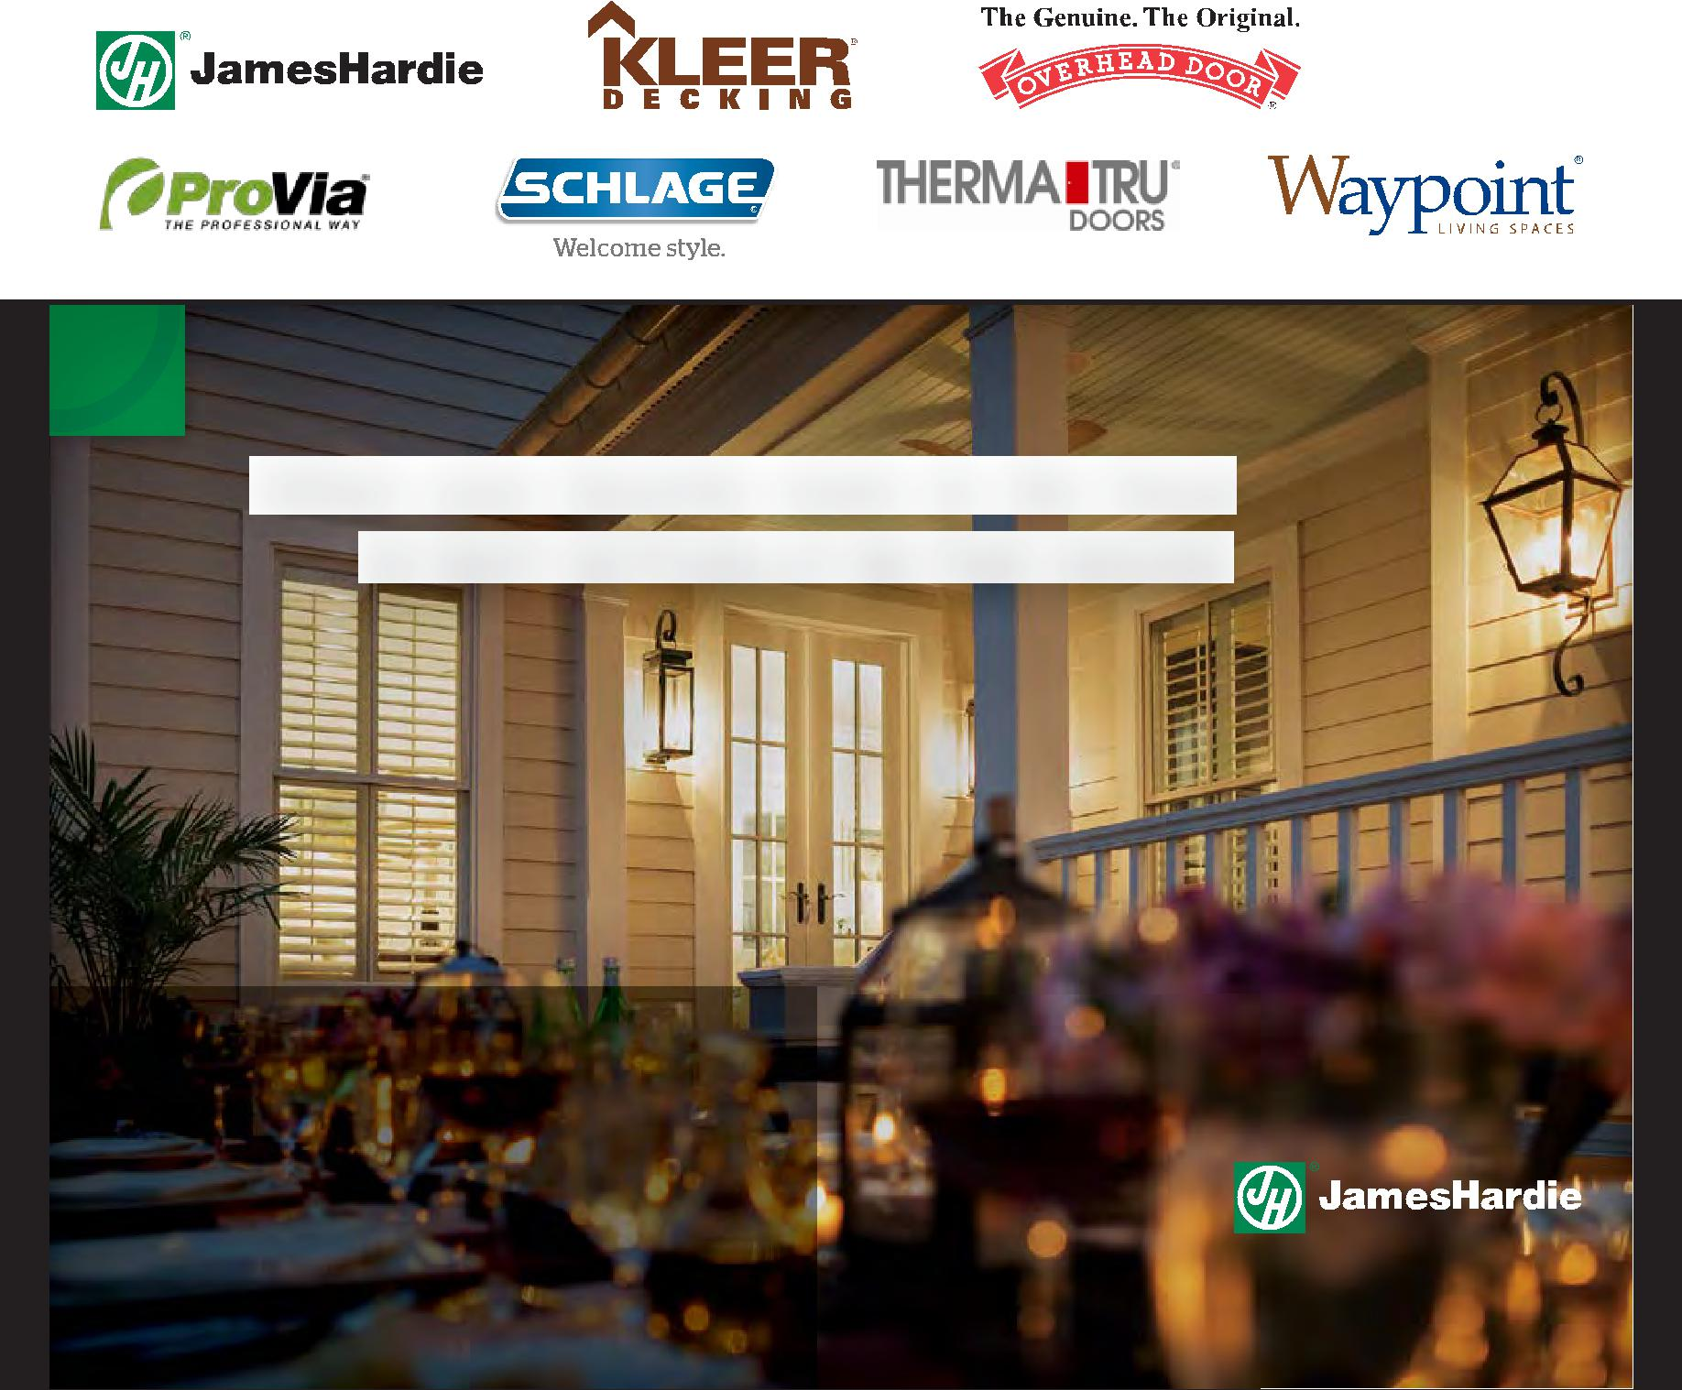

When your favorite room in the house

IS NOT ACTUALLY IN THE HOUSE.

We know a great little spot for dining out that’s right in the neighborhood.

The authentic, lasting character
of James Hardie® siding and trim
makes it hard to justify sitting
indoors – ever.
We build character. | Siding | Trim
jameshardie.com

© 2014 James Hardie Building Products Inc. All Rights Reserved. AD1484 12/14

YOUR OLD DECK:

YOUR NEW ONE:
UNSIGHTLY SCREWS.
STAINED AND FADED FINISH.
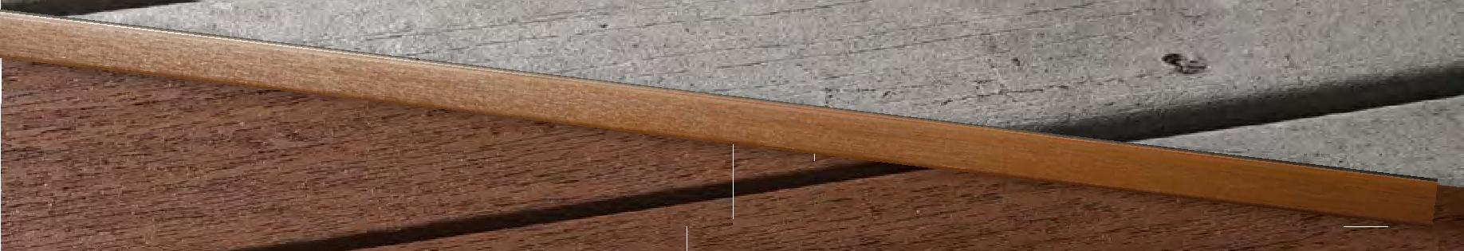

TOTALLY HIDDEN FASTENERS. 25-YEAR STAIN AND FADE WARRANTY.

Kleer Decking +PLUS. A complete system of innovative building solutions.

How do traditional decks compare to Kleer Decking +Plus? Frankly, there is no comparison. With a specially designed hidden fastener system, an industry leading 25-year stain and fade warranty, and a lifetime warranty that includes labor for the first two years, the deck you install today will look just as impressive for many tomorrows to come.

See how Kleer continues to think beyond wood at KleerDecking.com

A DIVISION OF THE TAPCO GROUP

SO COST EFFECTIVE it practically PAYS FOR ITSELF
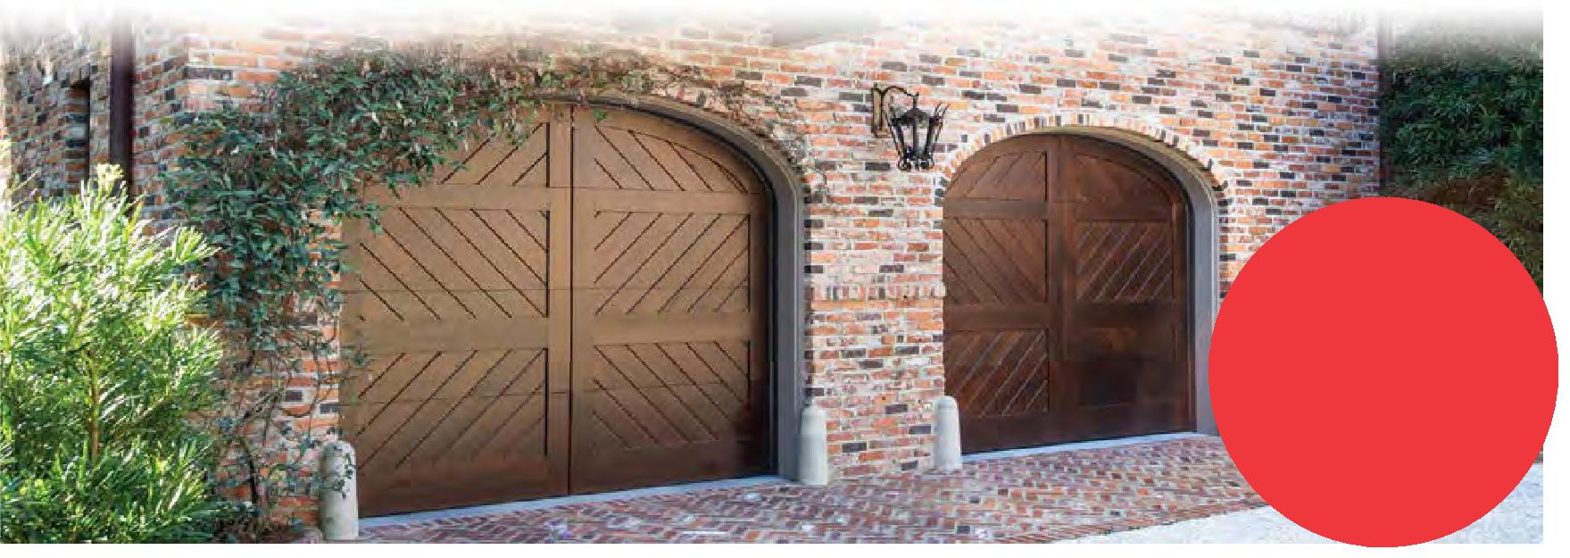

Named a
Top Ranked

project by

Remodeling

magazine*

Upgrading a garage door is one of the most cost effective renovations a homeowner can make.

In fact, according to the Cost vs. Value Report, replacing a basic garage door with an upgraded one from Overhead Door returned a remarkable 88.4% on original cost. Now, that’s a return on investment you can take to the bank.

* Based on National Association of Realtors members included in Cost vs. Value Study rather than actual sales
data. Complete data from the Remodeling 2015 Cost vs. _{www.OverheadDoor.com}

Value report can be downloaded at www.costvsvalue.com.

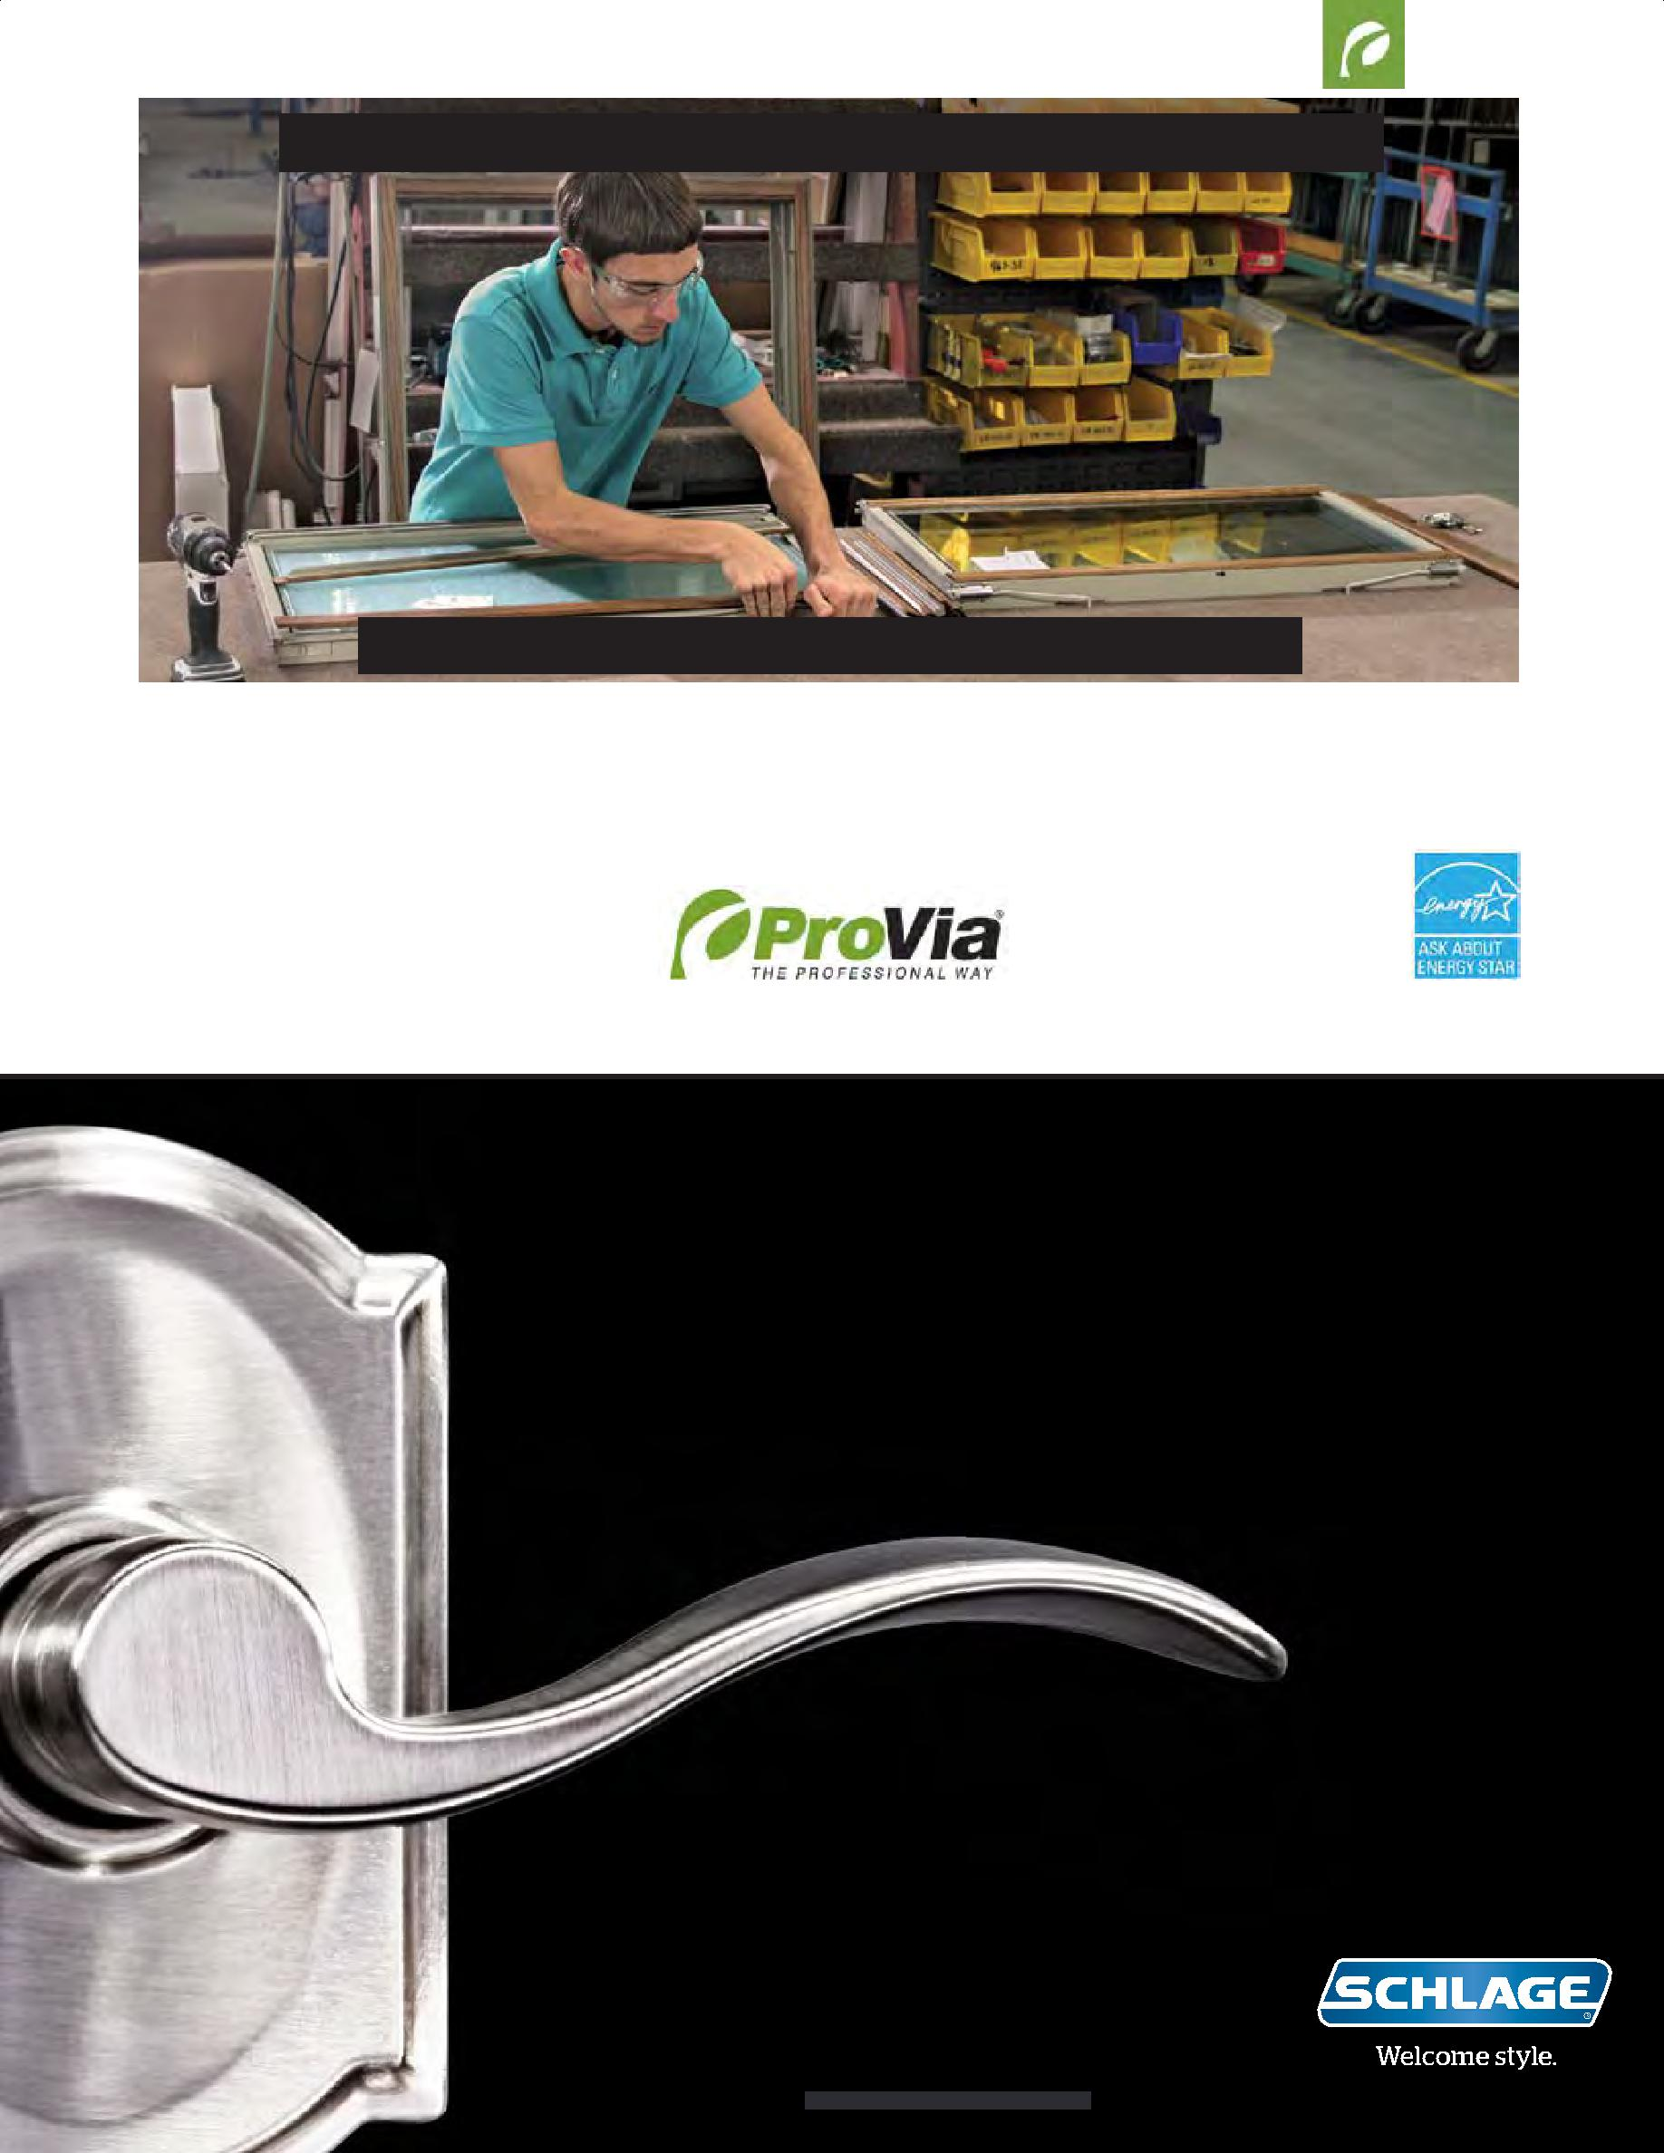
Who really cares about the details of your windows?

Michael Yoder of our Sugarcreek, OH facility does.

It’s a careful process for skilled workers to apply the precision-milled, furniture-grade wood components to the inside of an Aeris™ Wx1000 vinyl window sash. But it’s that expert human interaction that helps the wood pieces come together just right-- ultimately unveiling a beautiful and complete wood interior.

It’s our mission—to serve by caring for details in ways others won’t—that ensures the highest manufacturing standards. We’re building our products and our company to last a lifetime. That’s the Professional Way.

www.proviaproducts.com

The Professional Way is the only way at ProVia.

Where does personal style come from?

Is it born from an experience? A sight? A sound? A taste?

Does it arrive fully formed, or grow slowly over time?

Whatever its origins, one thing is certain:

It’s not just about where your style came from.

It’s where it takes you.

Explore thousands of looks that let you bring any vision to life. | schlage.com

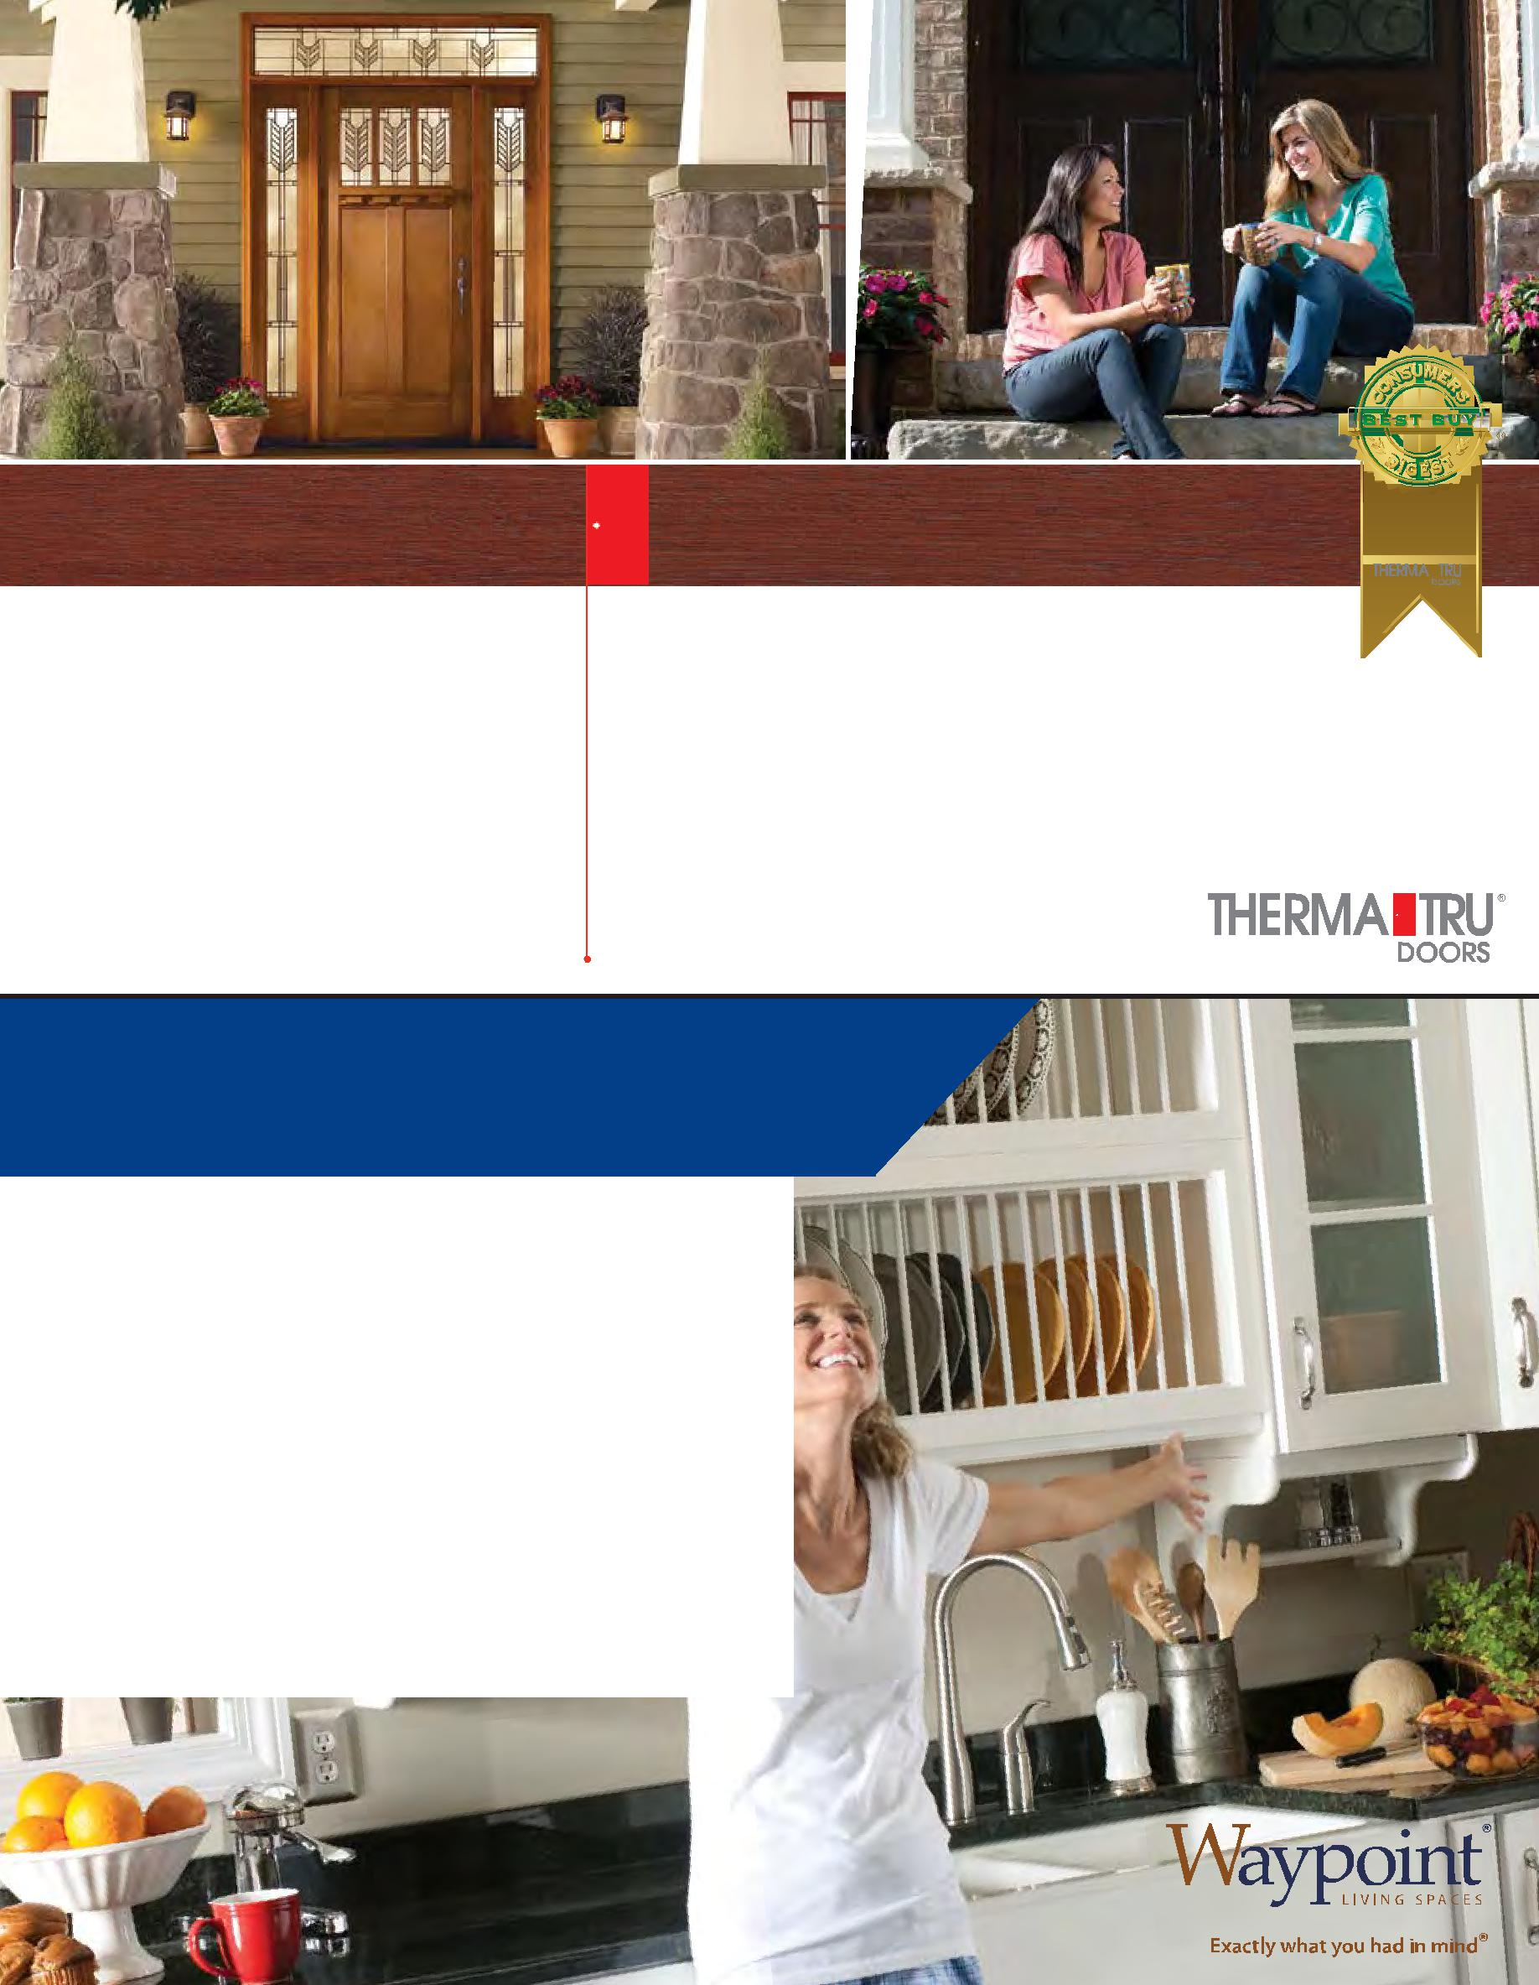

Classic-Craft®
Collection™
Entry Doors

Classic-Craft® | Extraordinary in every detail.
Premium Entryways
 | An inspired blend of precision engineering and architectural character
 | produce an entryway that performs as exceptionally as it looks.
 | View all five unique entryway collections.
 | www.thermatru.com/products/entry/fiberglass-entry-doors

Image: Classic-Craft® American Collection®, VillagerTM Glass,
Door – CCA232, Sidelites – CCA3402SL, Transom – VGRT, Dentil Shelf

©2015 Therma-Tru Corp. All rights reserved. The Best Buy Seal and other licensed materials are registered certification marks and trademarks of Consumers Digest Communications, LLC, used under license. For award information, visit ConsumersDigest.com. JAN 2015

adding st yle and value to your home is exhilarating!

Getting the style you want in a remodel has never been easier. Waypoint’s quality cabinetry, decorative accessories and organization options can create the look you want and add value to your home with style!

Go to waypointlivingspaces.com to find your style and a dealer near you.

